**ARDUINO SENSOR PROJECT**

1.ULTRASONIC SENSOR

**Circuit Diagram**:

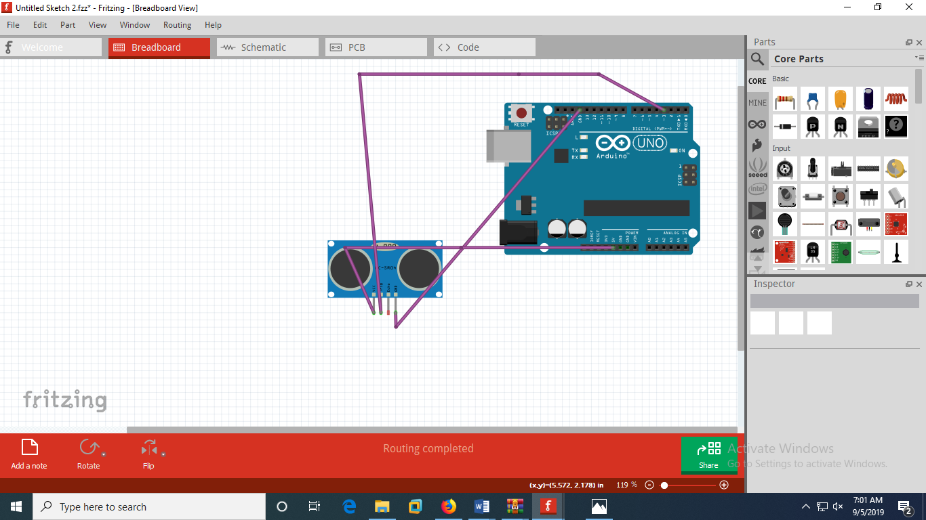

**Code:**

const int trigPin = 3;  
const int echoPin = 4;

long duration;  
int distance;  
  
void setup()   
{  
pinMode(trigPin, OUTPUT);   
pinMode(echoPin, INPUT);   
Serial.begin(9600);   
}  
  
void loop()   
{  
// Clears the trigPin  
digitalWrite(trigPin, LOW);  
delayMicroseconds(2);  
digitalWrite(trigPin, HIGH);  
delayMicroseconds(10);  
digitalWrite(trigPin, LOW);  
duration = pulseIn(echoPin, HIGH);  
distance= duration*0.034/2;  
  
  
Serial.print("Distance: ");  
Serial.println(distance);

delay(9600);  
}

**Datasheet**:

Ultrasonic Ranging Module HC - SR04

Product features:

Ultrasonic ranging module HC - SR04 provides 2cm - 400cm non-contact measurement function, the ranging accuracy can reach to 3mm. The modules includes ultrasonic transmitters, receiver and control circuit.

The basic principle of work:

(1) Using IO trigger for at least 10us high level signal,

(2) The Module automatically sends eight 40 kHz and detect whether there is a pulse signal back

(3) IF the signal back, through high level , time of high output IO duration is the time from sending ultrasonic to returning.

Test distance = (high level time×velocity of sound (340M/S) / 2,

Wire connecting direct as following:

5V Supply

Trigger Pulse Input

Echo Pulse Output

0V Ground

Electric Parameter

Working Voltage -DC 5 V

Working Current -15mA

Working Frequency - 40Hz

Max Range -4m

Min Range - 2cm

Measuring Angle -15 degree

Trigger Input Signal - 10uS TTL pulse

Echo Output Signal - Input TTL lever signal and the range in proportion Dimension 45*20*15mm

Vcc Trig Echo GND

Timing diagram

The Timing diagram is shown below. You only need to supply a short 10uS pulse to the trigger input to start the ranging, and then the module will send out an 8 cycle burst of ultrasound at 40 kHz and raise its echo. The Echo is a distance object that is pulse width and the range in proportion .You can calculate the range through the time interval between sending trigger signal and receiving echo signal. Formula: uS / 58 = centimeters or uS / 148 =inch; or: the range = high level time * velocity (340M/S) / 2; we suggest to use over 60ms measurement cycle, in order to prevent trigger signal to the echo signal.

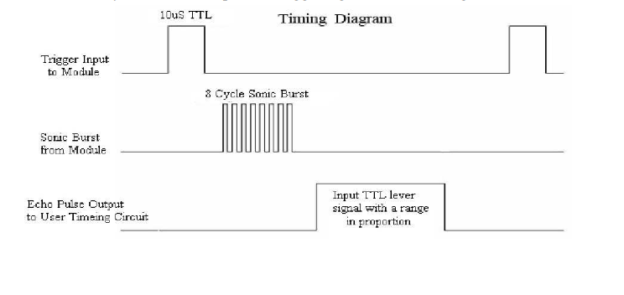

**OUTPUT:**

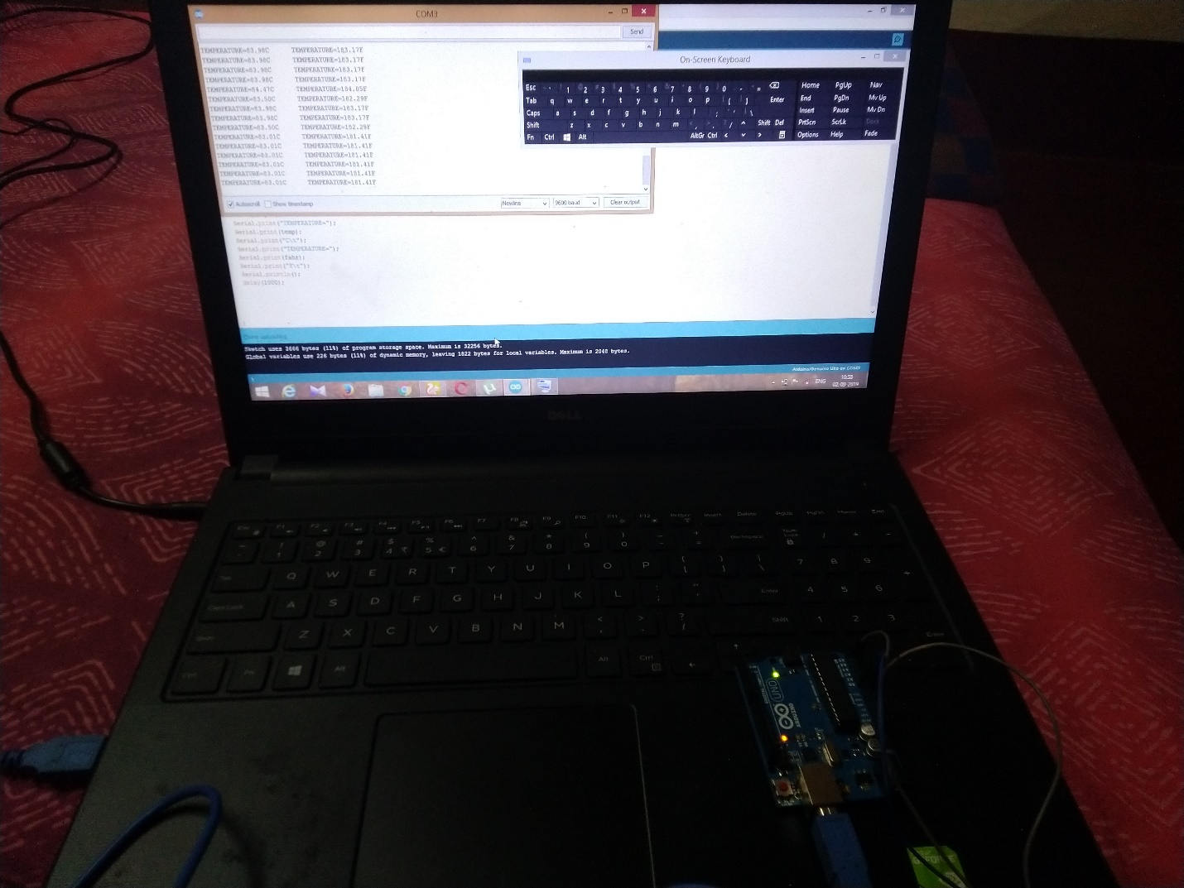

2**.**TEMPERATURE SENSOR

**Circuit Diagram:**

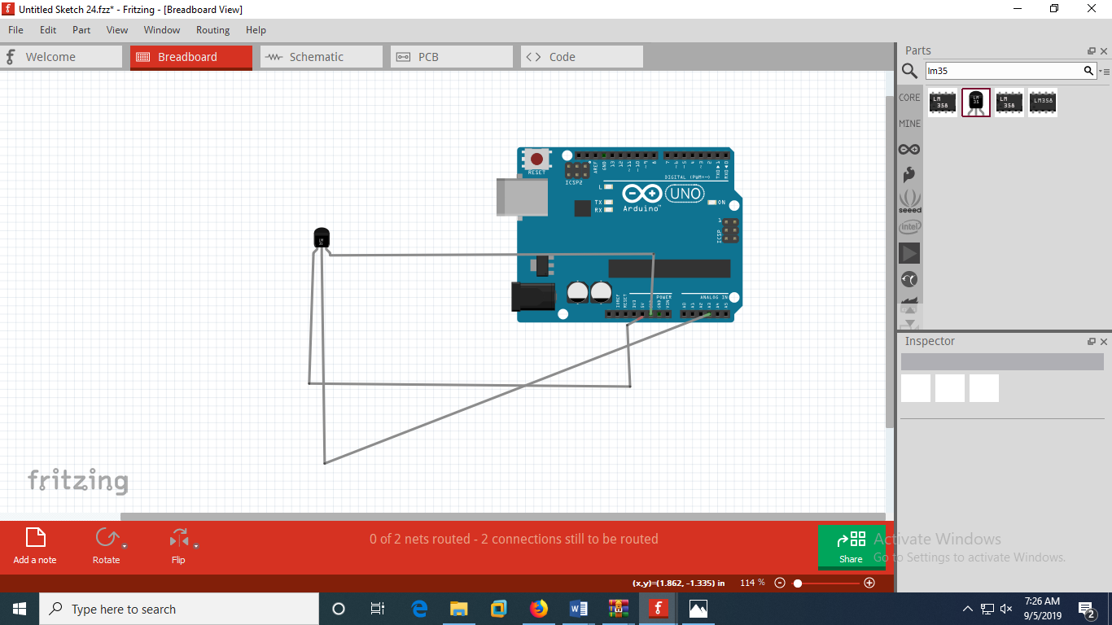

**Code:**

float temp;  
float fahr;  
int tempPin=A0;  
  
void setup()   
{  
    
Serial.begin(9600);  
  
}  
  
void loop()   
{  
  temp=analogRead(tempPin);  
  temp=temp*0.48828125;  
  fahr=(temp*9)/5+32;  
  Serial.print("TEMPERATURE=");  
  Serial.print(temp);  
  Serial.print("C\t");  
  Serial.print("TEMPERATURE=");  
  Serial.print(fahr);  
  Serial.print("F\t");  
  Serial.println();  
  delay(1000);  
  }

**Datasheet:**

LM35 Regulator Features:

* Minimum and Maximum Input Voltage is 35V and -2V respectively. Typically 5V.
* Can measure temperature ranging from -55°C to 150°C
* Output voltage is directly proportional (Linear) to temperature (i.e.) there will be a rise of 10mV (0.01V) for every 1°C rise in temperature.
* ±0.5°C  Accuracy
* Drain current is less than 60uA
* Low cost temperature sensor
* Small and hence suitable for remote applications
* Available in TO-92, TO-220, TO-CAN and SOIC package

How to use LM35 Temperature Sensor:

LM35 is a precession Integrated circuit Temperature sensor, whose output voltage varies, based on the temperature around it. It is a small and cheap IC which can be used to measure temperature anywhere between -55°C to 150°C. It can easily be interfaced with any Microcontroller that has ADC function or any development platform like Arduino.

Power the IC by applying a regulated voltage like +5V (VS) to the input pin and connected the ground pin to the ground of the circuit. Now, you can measure the temperate in form of voltage as shown below.

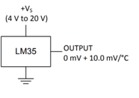

If the temperature is 0°C, then the output voltage will also be 0V. There will be rise of 0.01V (10mV) for every degree Celsius rise in temperature.  The voltage can converted into temperature using the below formulae.

VOUT=10mv/c*T

LM35 Temperature Sensor Applications:

* Measuring temperature of a particular environment
* Providing thermal shutdown for a circuit/component
* Monitoring Battery Temperature
* Measuring Temperatures for HVAC applications.

**Output:**

